EXPERIMENT 1
IMPLEMENTATION OF CAESAR CIPHER
AIM:
To implement the simple substitution technique named Caesar cipher using C language.

ALGORITHM:
STEP-1: Read the plain text from the user.
STEP-2: Read the key value from the user.
STEP-3: If the key is positive then encrypt the text by adding the key with each
character in the plain text.
STEP-4: Else subtract the key from the plain text.
STEP-5: Display the cipher text obtained above.

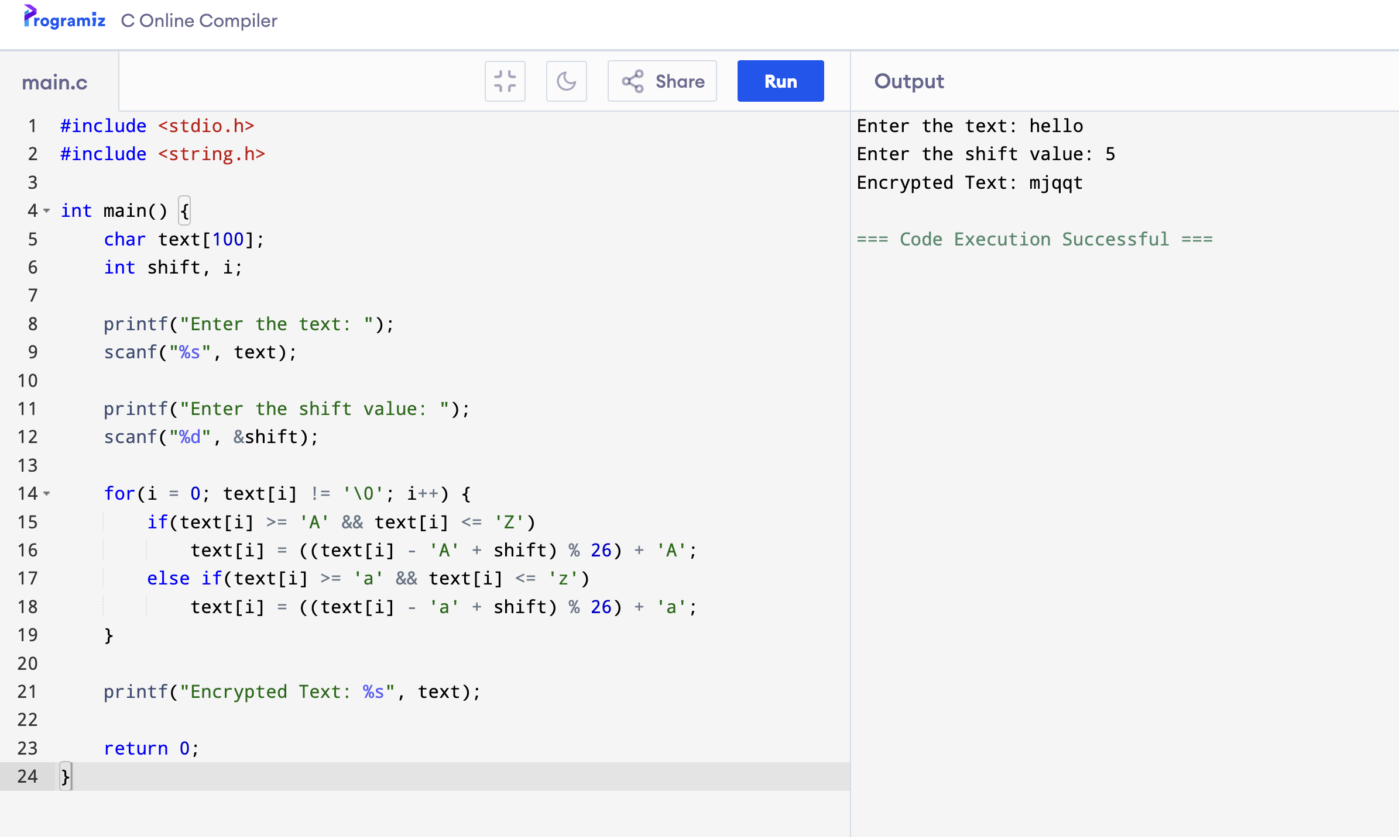

INPUT:

